# Instructions to generate WSDLs code for Shiplinx Web Services

## WSDL Code Generation

### WSDL Files

1. RatingService.wsdl
2. ShippingService.wsdl

### XSD Files

1. Datatypes.xsd
2. RatingRequest.xsd
3. RatingResponse.xsd
4. ShippingRequest.xsd
5. ShippingResponse.xsd

### Command Files

1. genRatingService.bat
2. genShippingService.bat

### Instructions to unzip

1. Unzip ws_gen.zip file to any folder
2. Following files / folders will be unzipped

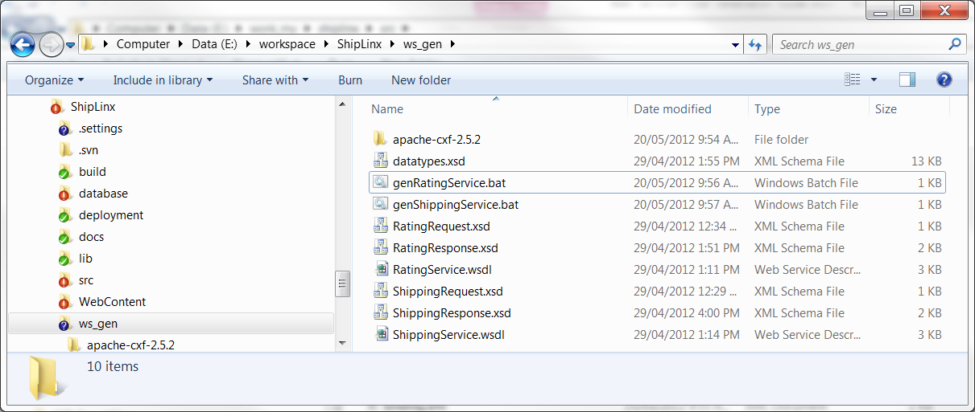

### Instructions to generate code for RatingService wsdl

1. Open genRatingService.bat in notepad
2. Make sure to SET JAVA_HOME path correctly
3. Open DOS BOX in the folder where you unzipped files
4. Run genRatingService.bat file
5. It will generate following files / folders

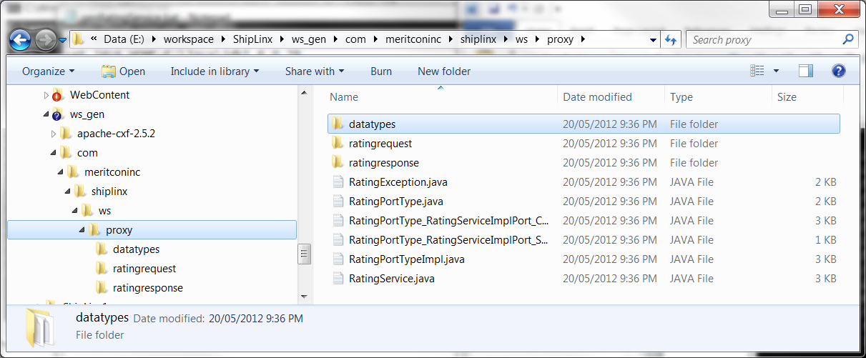

### Instructions to generate code for ShippingService.wsdl

1. Open genShippingService.bat in notepad
2. Make sure to SET JAVA_HOME path correctly
3. Open DOS BOX in the folder where you unzipped files
4. Run genShippingService.bat file
5. It will generate following additional files / folders

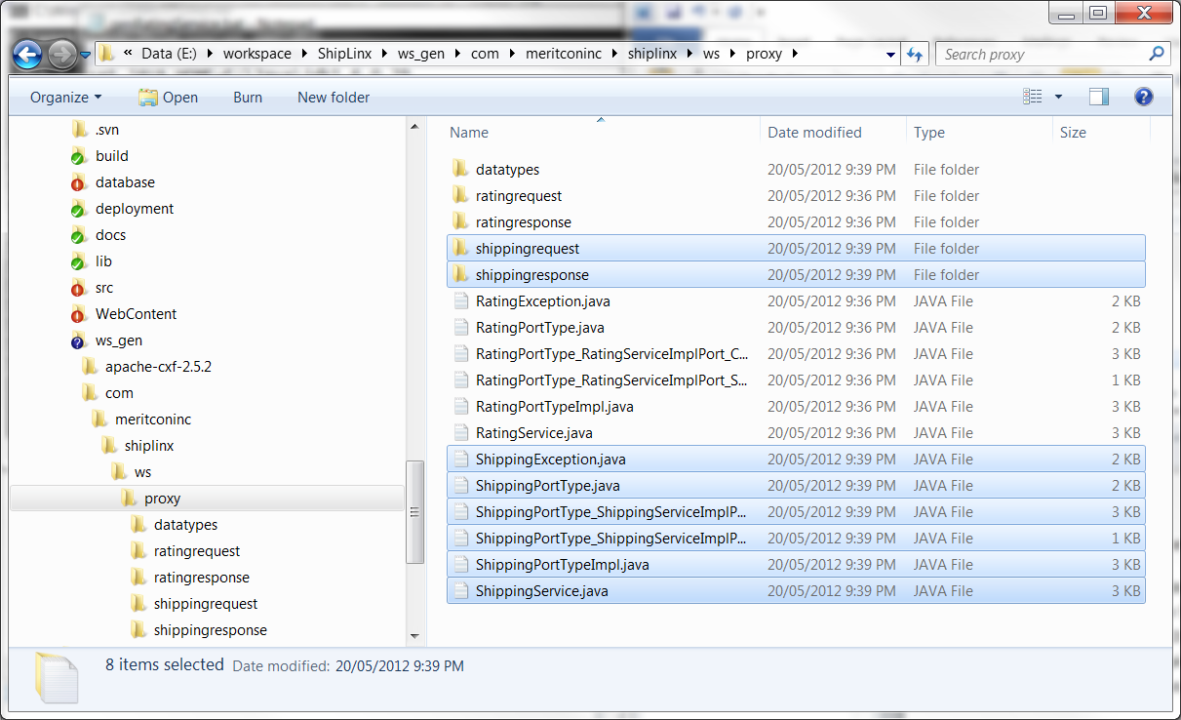

### XSD Files Modifications

* If you modify any file then you should only copy specified folder to the source folder and compile.

|  |  |  |
| --- | --- | --- |
| **File Name** | **Folder Name** | **Description** |
| Datatypes.xsd | com\..\..\ws\proxy\datatypes |  |
| RatingRequest.xsd | com\..\..\ws\proxy\ratingrequest |  |
| RatingResponse.xsd | com\..\..\ws\proxy\ratingresponse |  |
| ShippingRequest.xsd | com\..\..\ws\proxy\shippingrequest |  |
| ShippingResponse.xsd | com\..\..\ws\proxy\shippingresponse |  |